Staircase Problem

Problem
A person can climb one, two or three stairs at a time. Find the number of ways in which he can climb n^{th} stairs.

Example
n = 5

Ways:
{1, 1, 1, 1, 1}
{1, 1, 1, 2}
{1, 1, 2, 1}
{1, 2, 1, 1}
{2, 1, 1, 1}
{1, 2, 2}
{2, 1, 2}
{2, 2, 1}
{1, 1, 3}
{1, 3, 1}
{3, 1, 1}
{2, 3}
{3, 2}

Hence total number of ways = 13.

It can be easily seen that
f(n) = f(n-1) + f(n-2) + f(n-3)

Since it can be represented as Recurrence Relation, therefore it has an optimal substructure property.

Checking whether it has overlapping subproblem property
Making recursion tree

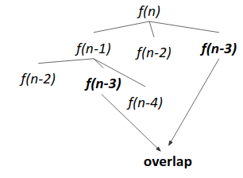

Since f(n-3) repeats, it follows overlapping subproblem property.

Approach 1 (Memoization)
- Write the recursive solution.
- Memoize it.

Approach 2 (Tabulation)
- Initialize f(0)=1, f(1)=1, f(2)=2.
- Iterate from i=3 to i=n, and keep applying f(i) = f(i-1) + f(i-2) + f(i-3).
- Output f(n).

Code
